**CSE523 Machine Learning**

**Prof. Mehul Raval**

**Time Series Sales Forecasting using Machine Learning Algorithms**

**Week-2 Progress Report**

| **Name** | **Enrolment Number** |
| --- | --- |
| Soham Jagrit | AU2040060 |
| Nitya Panchal | AU2040249 |
| Freya Shah | AU2020039 |
| Gunisha Giri | AU2020210 |

**Week-4**

**Work we did**

* This week we tried to pre-process the data for the models. We are facing minor issues with the data pre-processing but they will be solved this week.
* **The understanding part:** All of us have had a reading of the research papers and now we are familiar with the concept.
* **The writing part:** Talking about the report and presentation part, we started the draft and gathered information about the previous work and abstract.
* **The implementing part:** We are facing an error in casting the date-time type to the timestamp datatype(float). Here is the code snippet:
  + 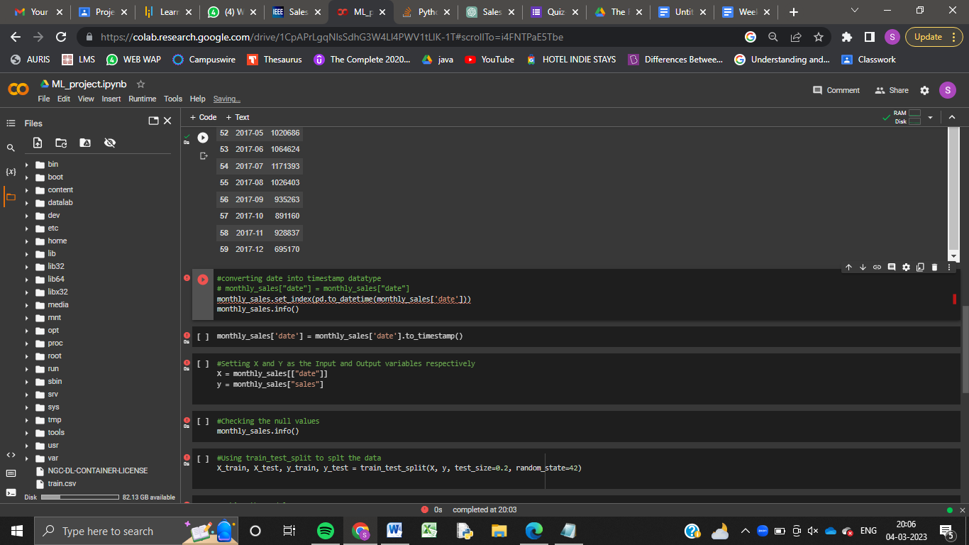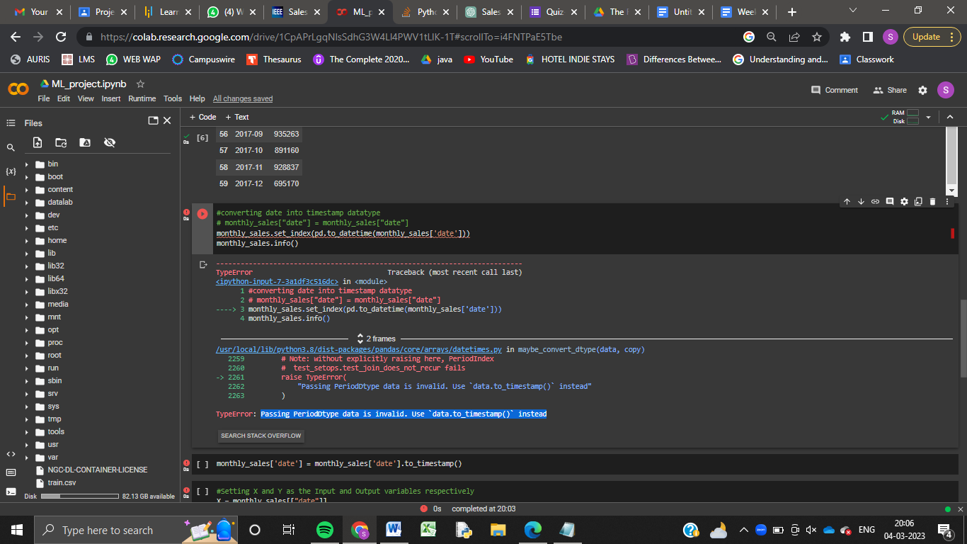

**Tasks for next week**

* Complete the report and make the presentation.
* Complete the data pre-processing and start the implementation and making the model.